How to Configure HMA to TrafficBotPro

Step 1: Open your "Control Panel" and click on "Network and Internet"
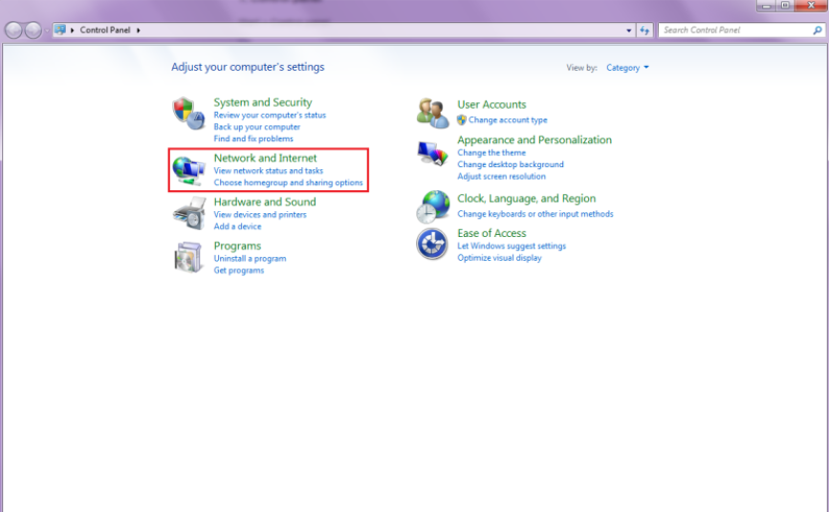

Step 2: Select "Set up a new connection or network"
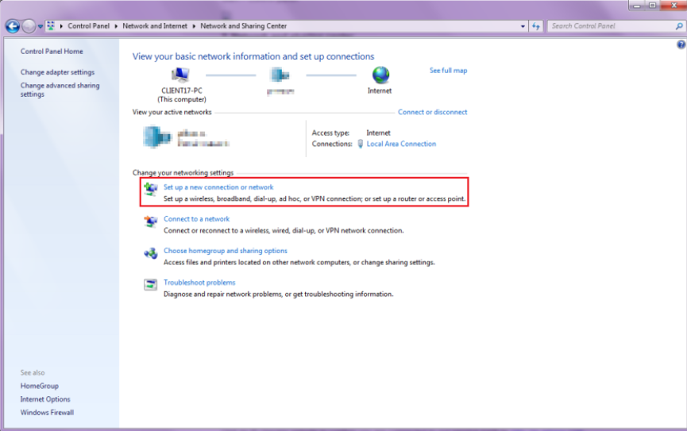

Step 3: Select "Connect to a workplace" and then click on "Next"
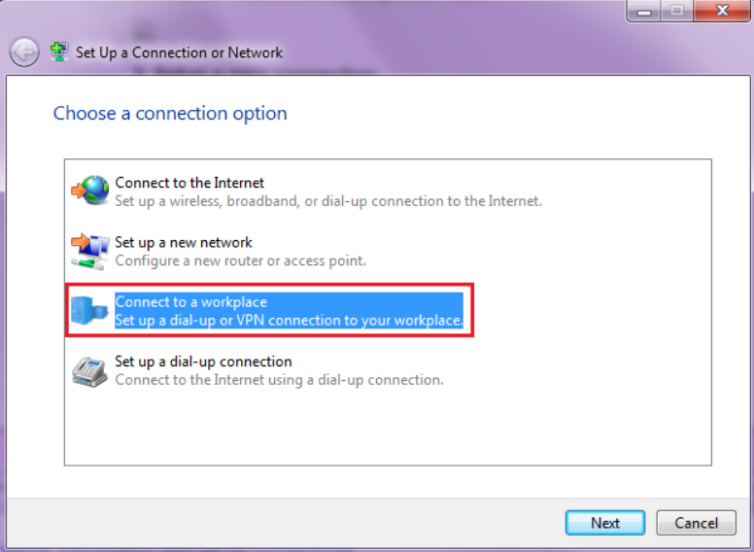

Step 4: In the next window, select "No, create a new connection" and then click on "Use my internet connection (VPN)". When you do, a window will appear where you'll need to enter the following:
Internet address: Select any of the VPN server names you can find in the VPN Control Panel.
Destination name: It can be anything you like, something recognizable, like "HMA!"
When you're done, click "Next"
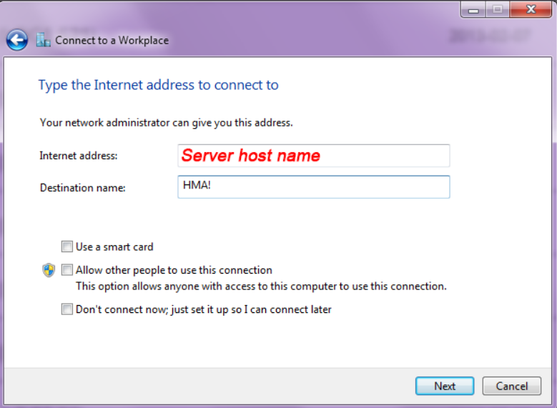

Step 5: Now you'll need to enter your HMA! credentials as follows:
User name: Enter your HMA! account username
Password: Type your special IPSec password. This can be found by logging into the VPN Control Panel.
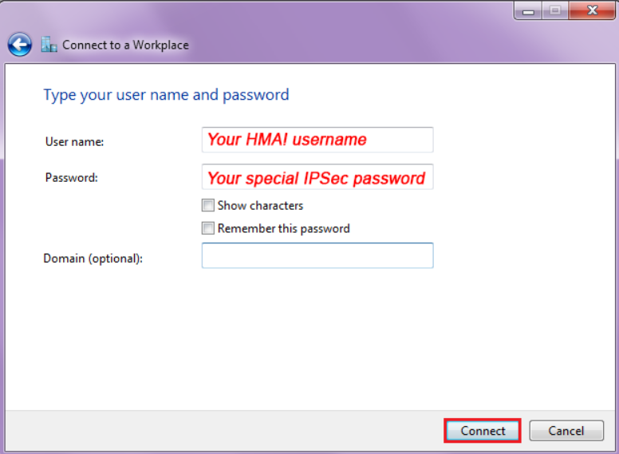
Once you're connected, you can verify your location and IP address by browsing to https://whatismyipaddress.com/

The above configure is to confirm if HMA works in your browser. If it works well, then please enter the same data in TrafficBotPro. Software will auto connect when you start to run the campaign.
